Student’s name | …………………………………………………….…… | Grade | 3
Subject | Computer | Quiz No. | 1
Quiz No. ( 1 )

10

write the correct name of each part.

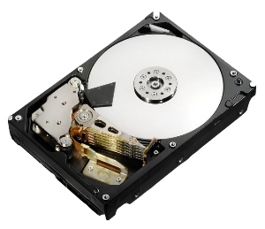
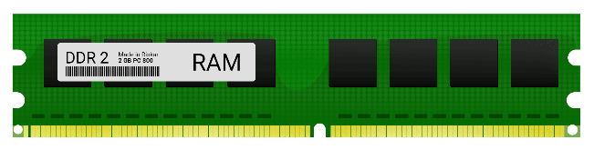
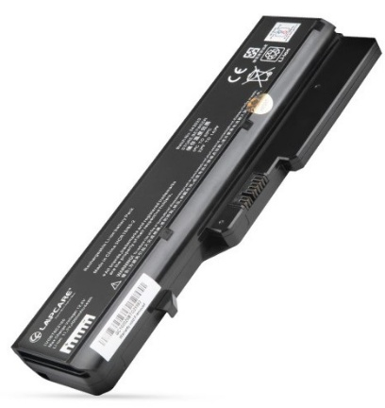
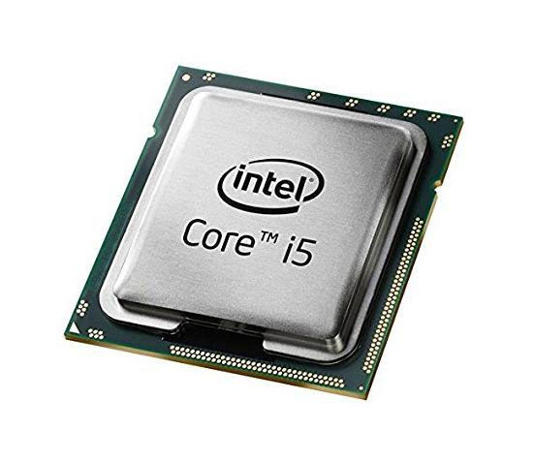
Good Luck

Hard Disk
Battery Laptop
RAM
Vector
CPU

